## 1. about certificate

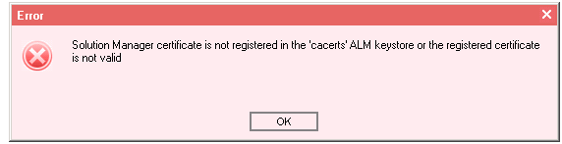

import SSL.cert into cacarts in ProgramFiles (no need to restart)

if accessing EIServer get 403 forbidden error, might need to add full license in SiteAdmin

if during update test result met with An exception occurred: Signing certificate of the SOAP message is not trusted, and cannot keyword mapping, check Issuer certificate in SAML2, should be the SAML certificate of ALM (serial number need to be matched)

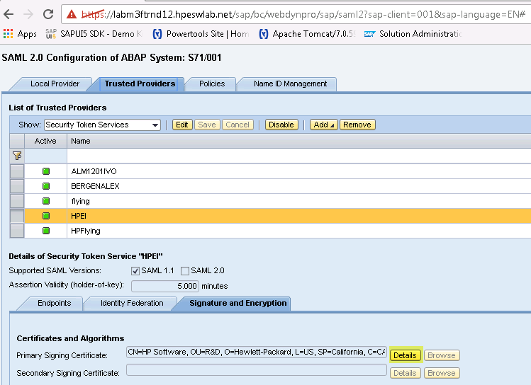

*About SSL Server Certificate*

If Server change domain then get unknown hostname when import SolDoc

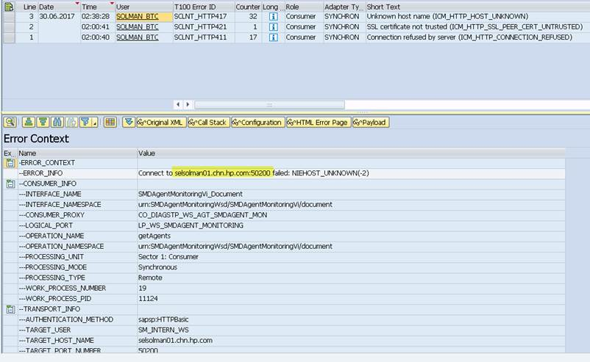

The CN in certificate should be  the same as a machine name.

You need edit the CN in certificate. (right click parent folder and change)

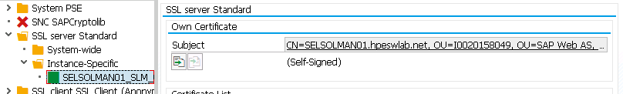

SAML certificate algorithm shall be rsa instead of dsa

Below services in STRUST shall be enabled

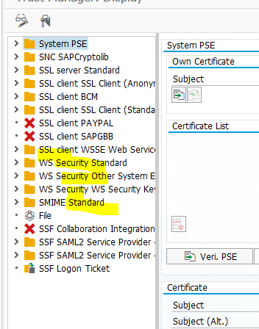

#### Comfigure AGS_SM_BLUEPRINT API in Partner Connection (7.2)

If met with SOAP 500 error, the SSL certificate might be wrong

Troubleshooting: use KeyStore Explorer 5.1 to create one JKS Certificate, generate key pair with RSA algorithm, input server domain name or ip in CN

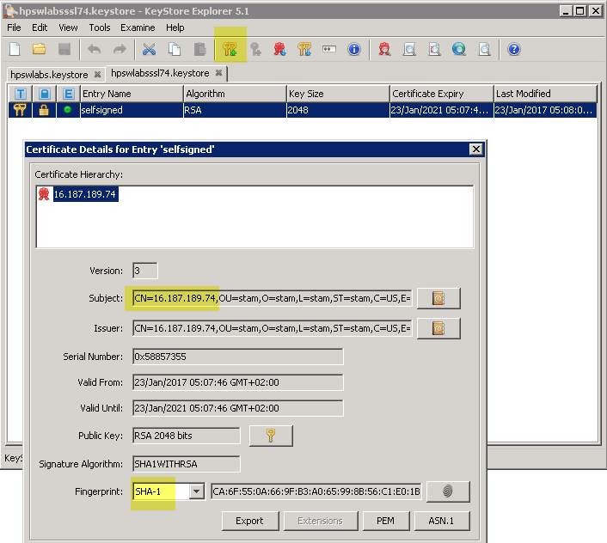

Push in one folder and store the path in jetty-ssl.xml, restart server, export from browser, trust in Solman strust SSL Client standard and anonymous



The path of cacerts need to be update with valid one

*run_ei_configurator.bat*

DB configuration is siteadmin.xml from program data/…/20qcbin/..., can set parameter to directly point to the file if met DB error

## 2. associate project

Met application error: need to add user qa in SiteAdmin

You can validate also a part of associating an existent project, if you want :-)

But you have to create a flag manually

ENABLE_EI_AUTO_USER_CREATION_UPON_PROJECT_ASSOCIATION = Y

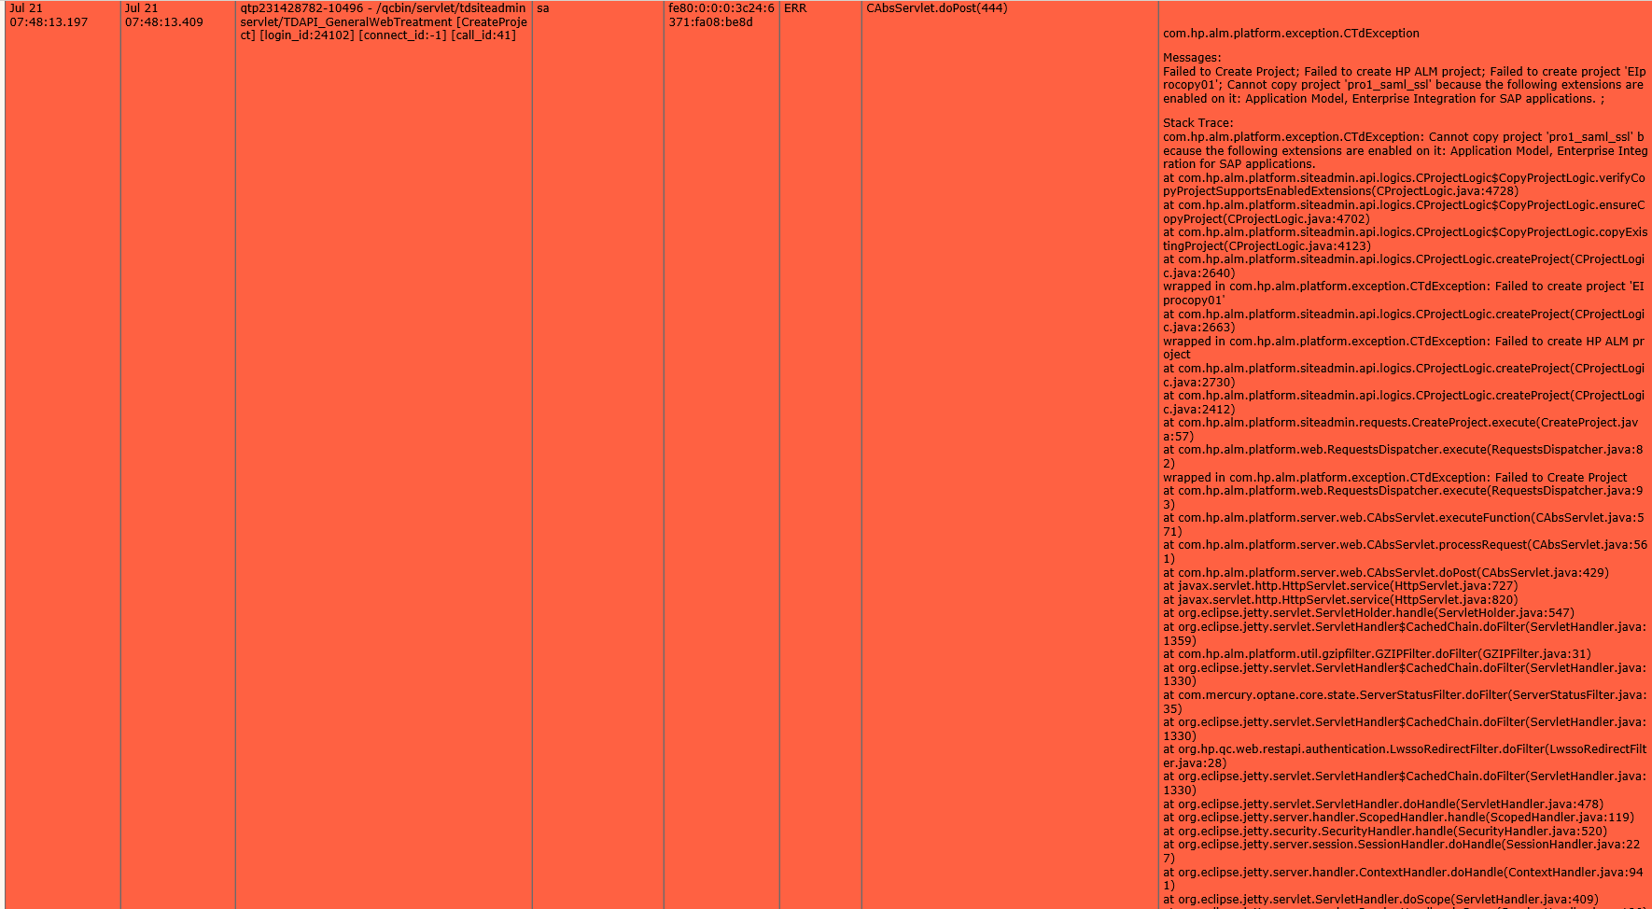

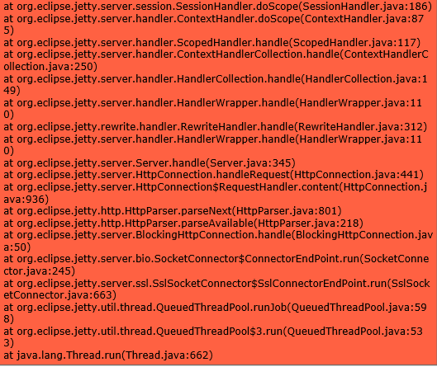

we need to create a site parameter

ENABLE_COPY_PROJECT_EXTENSION_COMBINATION_SUPPORT

N

first part is the name

second part is the value

please create the parameter first before you copy project

please add this to the your notes and the wiki if it's possible :D

need to adjust the minute:

|  |
| --- |
| INFO | jvm 1 | 2015/08/12 14:43:47.059 | drBVaP8Ke5ozEbDLg+o=</ds:SignatureValue><ds:KeyInfo><wsse:SecurityTokenReference><wsse:Reference URI="#bst-28924A3992F61ED5909E036732C7" ValueType="http://docs.oasis-open.org/wss/2004/01/oasis-200401-wss-x509-token-profile-1.0#X509v3"/></wsse:SecurityTokenReference></ds:KeyInfo></ds:Signature><wsse:SecurityTokenReference wsu:Id="str-28924A3992F61ED5909E036732C71213"><wsse:KeyIdentifier ValueType="http://docs.oasis-open.org/wss/oasis-wss-saml-token-profile-1.0#SAMLAssertionID">saml-28924A3992F61ED5909E036732C6B213</wsse:KeyIdentifier></wsse:SecurityTokenReference><saml:Assertion MajorVersion="1" MinorVersion="1" AssertionID="saml-28924A3992F61ED5909E036732C6B213" Issuer="HP" IssueInstant="2015-08-12T12:46:17Z" xmlns:saml="urn:oasis:names:tc:SAML:1.0:assertion"><saml:Conditions **NotBefore**="2015-08-12T12:46:17Z" **NotOnOrAfter**="2015-08-12T12:51:17Z"/><saml:AuthenticationStatement AuthenticationMethod="urn:oasis:names:tc:SAML:1.0:am:unspecified" AuthenticationInstant="2015-08-12T12:46:17Z"><saml:Subject><saml:NameIdentifier NameQualifier="" Format="urn:oasis:names:tc:SAML:1.1:nameid-format:unspecified">QA01</saml:NameIdentifier><saml:SubjectConfirmation><saml:ConfirmationMethod>urn:oasis:names:tc:SAML:1.0:cm:sender-vouches</saml:ConfirmationMethod></saml:SubjectConfirmation></saml:Subject></saml:AuthenticationStatement></saml:Assertion></wsse:Security><sap:Trace wsu:Id="part-Trace-30" xmlns:sap="http://www.sap.com/webas/630/soap/features/runtime/tracing/"><sap:TraceLevel>Error</sap:TraceLevel><sap:TraceContext><TRC_PATTERN>WSTEST</TRC_PATTERN><TRC_KEY>9ED340E5C9F4F1A5921328924A3992F6</TRC_KEY><TRC_ROOT_CTX_ID/><TRC_SSID>SLM_00</TRC_SSID><TRC_USER>QA01</TRC_USER><TRC_TS>20150812092232</TRC_TS><TRC_COUNTER>85</TRC_COUNTER><TRC_EXTERN/><TRC_REQBASED/><TRC_PPVERS>2</TRC_PPVERS></sap:TraceContext></sap:Trace></soap-env:Header><soap-env:Body wsu:Id="part-Body-31" xmlns:wsu="http://docs.oasis-open.org/wss/2004/01/oasis-200401-wss-wssecurity-utility-1.0.xsd"><nm:AgsSmGetExtToolProjects xmlns:nm="urn:sap-com:document:sap:soap:functions:mc-style" xmlns:prx="urn:sap.com:proxy:SLM:/1SAI/TAS0166452209D5BDA0F8EB:702"/></soap-env:Body></soap-env:Envelope> |

If “General security error (SAML token security failure)” also need adjust the time:

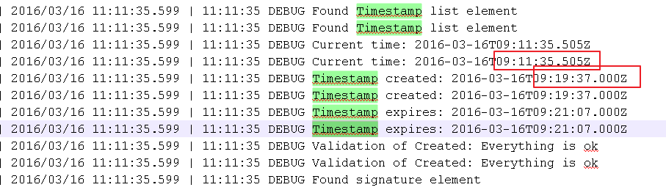

Take the snapshot for example, time of alm server need to change from 9:11 to 9:19

If crypto properties null, may due to crypto.properties and cryptoClient.properties missing

Besides, if nodes in solman with same name cannot be push to ALM, you can add EI_REQ_SEARCH_IN_PARENT in site admin parameter

Field mapping, get: cannot login to QC:Invocation of Login failed

From util, see the association is using wrong logical port

Solution: Associate project first, then map successfully

Link stored in table blueprint:

https://fbt.wdf.sap.corp:44390/sap/bc/webdynpro/sap/wdc_adapter_admin_center?sap-wd-client=200&association={XO{VzLc7kQalkqT84EKUG

<http://pvs9216.wdf.sap.corp:8000/sap/bc/webdynpro/sap/wdc_adapter_admin_center?sap-wd-client=001&association=01LT018i7jQbxMwFxQqK1G>

#### Manually add association relationship for deassociation

Insert into DEFAULT_EI1253P2910_DB0.BLUEPRINTS (SPI_BL_ID,SPI_BL_REQ_ID,SPI_BL_APP_ID,SPI_BL_SM_PROJ_ID,SPI_BL_SM_URL,SPI_SD_SM_URL,SPI_BL_PARENT_SM_PROJ_ID,SPI_BL_PARENT_HP_DOMAIN_NAME,SPI_BL_PARENT_HP_PROJ_NAME,SPI_BL_SM_ASSOCIATION_ID,SPI_BL_ROOT_PATH,SPI_ADD_SD_SM_URL,SPI_BL_UPDATE_STAT,SPI_BL_UPDATE_STAT_NOTES,SPI_BL_LAST_SYNC_T,SPI_BL_PUSH_BP_URL,SPI_BL_EXTERNAL_GUID,SPI_BRANCH_EXPORT_LIB_ID,SPI_BRANCH_IMPORT_LIB_ID) values (1,-1,1,'A99AEPBs7kQtbYQwYmlkoG','https://SELSOLMAN01.chn.hp.com/sap/bc/srt/rfc/sap/sm_bp_testresult_api/001/sm_testresult_api/binding','https://SELSOLMAN01.chn.hp.com/sap/bc/srt/rfc/sap/ict_service_desk_api/001/ict_service_desk_api72/binding',null,null,null,'A99AEPBs7kQufelCsShEoG','PRODUCTION','https://SELSOLMAN01.chn.hp.com/sap/bc/srt/rfc/sap/ags_sd_adapter_api/001/ags_sd_adapter_api/ags_sd_adapter_api_saml','New',null,'1970-01-01 00:00:00','http://selsolman01.chn.hp.com:50000/sap/bc/webdynpro/sap/wdc_adapter_admin_center?sap-wd-client=001&association=A99AEPBs7kQufelCsShEoG',' ',null,null);

#### For SolMan 7.2

If get error when selecting Partner Project in Partner Test Management

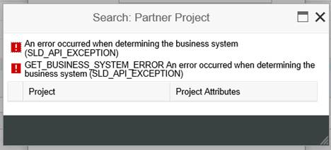

The logical port was not assigned in the “Define Partner Connection” step (solman_setup), remember click save before switching to configure lp of service desk

If project is not shown when creating association to get project list by AgsSmGetExtToolProjects, check if ei_integration_user is added in project user

## 3. Requirement

#### Import soldoc (7.2)

If met 403 error then go to SICF transaction… search for the service wdc_adapter_admin_center

This service must be in active state

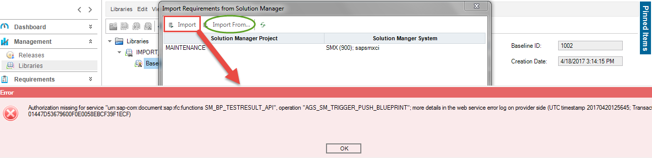

The SolMan User should have proper role to have the authentication permission.

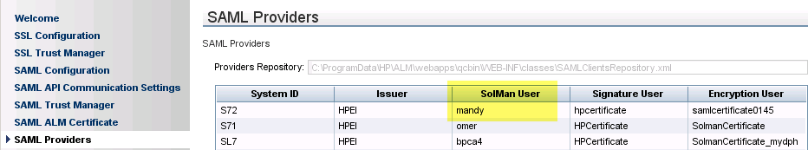

SolMan 7.2

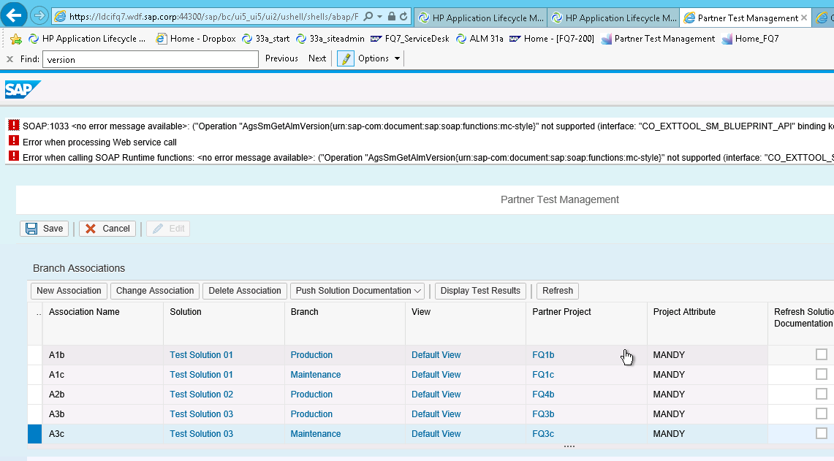

#### Customize fields sequence in requirement detail pane:

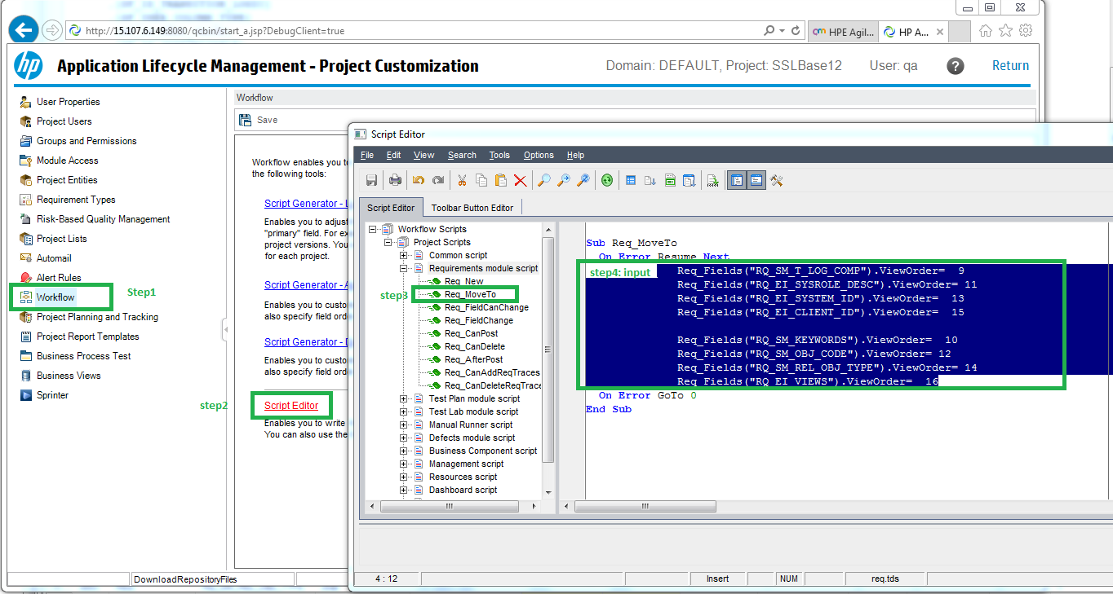

Req_FIelds("RQ_SM_T_LOG_COMP").ViewOrder=9

Req_FIelds("RQ_EI_SYSROLE_DESC").ViewOrder=11

Req_FIelds("RQ_EI_SYSTEM_ID").ViewOrder=13

Req_FIelds("RQ_EI_CLIENT_ID").ViewOrder=15

Req_FIelds("RQ_SM_KEYWORDS").ViewOrder=10

Req_FIelds("RQ_SM_OBJ_CODE").ViewOrder=12

Req_FIelds("RQ_SM_REL_OBJ_TYPE").ViewOrder=14

Req_FIelds("RQ_EI_VIEWS").ViewOrder=16

#### Push soldoc (7.2)

Need to assign system role to logical component group

Because Logical component group of folder is set by default to be the last LCG sent in SolDoc, so if it is not set then push will failed

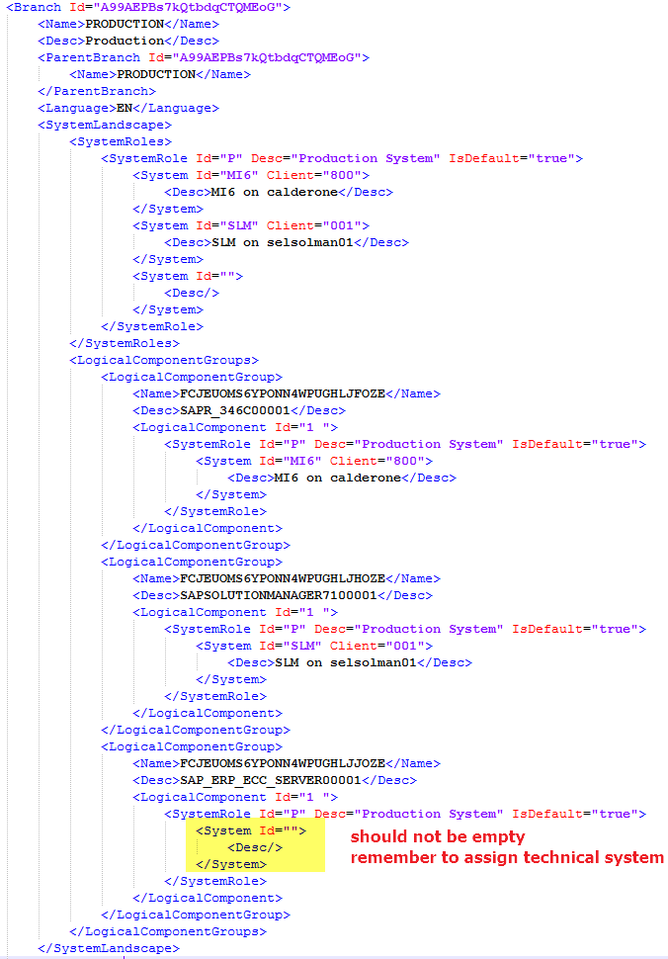

If push failed, try create a temp folder and move whole existing req from the third level to it, delete second level and then push:

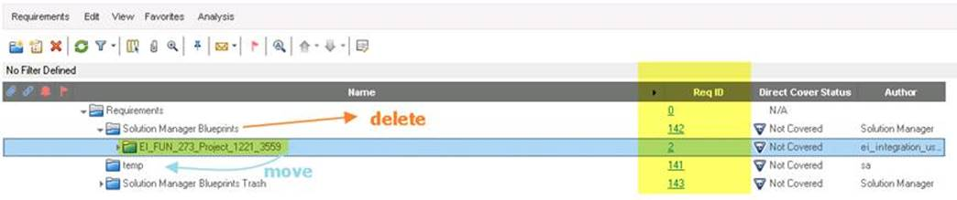

If still failed, try unselect some node and push

Performance:

27,000 Nodes will take 3 hours+ to finish the Push SolDoc event.

## 4. update result

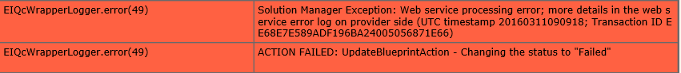

Web Service exception in saml mode

Check the saml wsdl of testdata for example should contain “security”, if not, copy the one under saml folder

If no result in blueprint, can check in transaction solar_eval

## 5. mapping field

when two project in SolMan connect to same project in QC, one only configure the blueprint testdata logical port, one configure the correct incident logical port, keymapping alert error as below

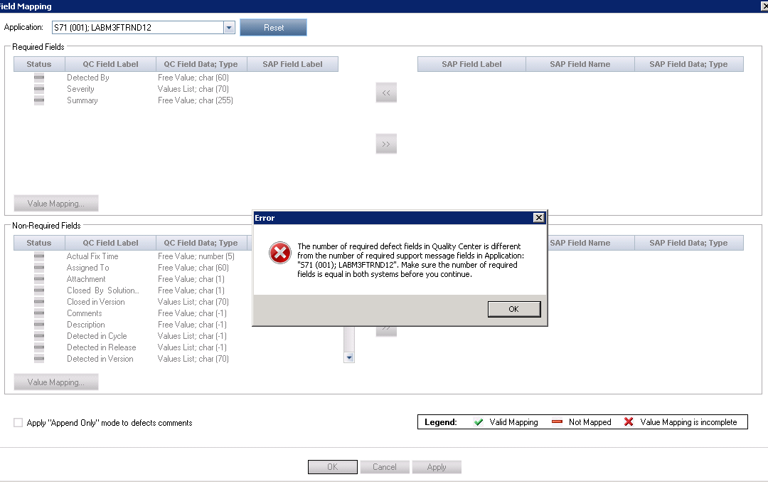

Or maybe the mode of SAML is not corresponding to the site configuration parameter value



Use ei_configurator.bat to enforce the settings and re-associate project

Or maybe check the service desk api in table Blueprint : if current is in SAML mode while the api url is not https, then need to check in ictconf and spro, then deassociate and associate again.

Or maybe check the file under C:\ProgramData\HP\ALM\webapps\qcbin\WEB-INF\classes\wsdl to be from the expected mode

HTTP response '401: Unauthorized' when communicating with <http://SELSOLMAN01.chn.hp.com:8000/sap/bc/srt/rfc/sap/ict_service_desk_api/001/ict_service_desk_api/ict_service_desk_api>

the binding “ICT_SERVICE_DESK_API”can not be opened due to login user be locked, use transaction su01 to unlock user, reassociate, problem gone

#### About PCICT Service Desk Logical port (7.2)

If met with SXML reader/writer exception, implement note 2316667 and 2297419

#### For SolMan 7.2

if met error, in wrapper log there is binding get 403 error, might be the ict_service_desk api is not activated in sicf

## 6. defect sync

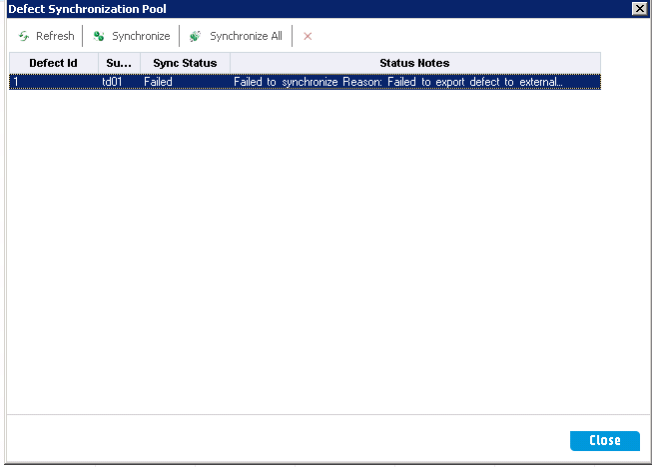

none saml mode also need these: ictconf and reassociate project

Create a new entry for the external test tool and assign the following objects (SPRO):

* **Logical port** for test management (consumer proxy type of CO_AGS_SM_TESTDATA_API ; SMB)  - blueprint
* End point for test management (service definition type of AGS_SM_TESTRESULT_API), use the binding name of the service definition
* **Logical port** for service desk management (consumer proxy type of CO_PCICT_SERVICE_DESK_API)
* End point for service desk management (service definition type of ICT_SERVICE_DESK_API), use the binding name of the service definition, should be ICT_SERVICE_DESK_API_SAML
* Logical port for service desk management extension (consumer proxy type of CO_AGS_SD_ADAPTER_API)
* End point for service desk management extension (service definition type of AGS_SD_ADAPTER_API), the binding name of the service definition, should be AGS_SD_ADAPTER_API_SAML

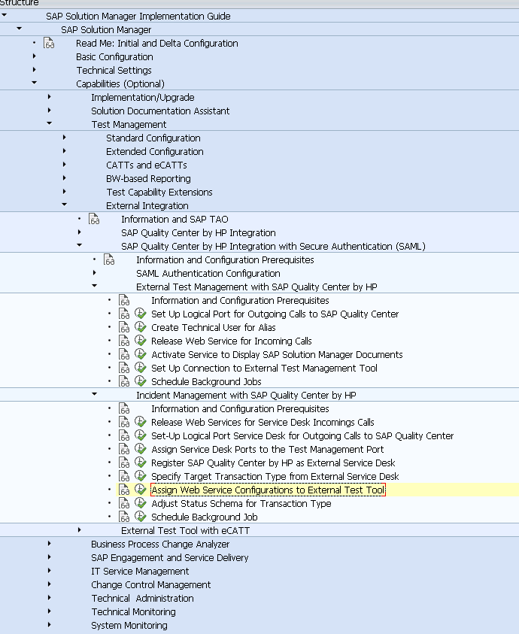

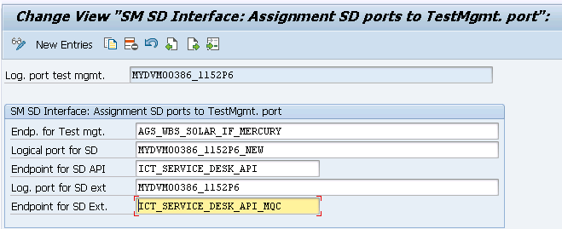

then reassociate project, remap field

When create incident, sync to solman failed, system id unknown: (todo : check ictconf and reassociate project )

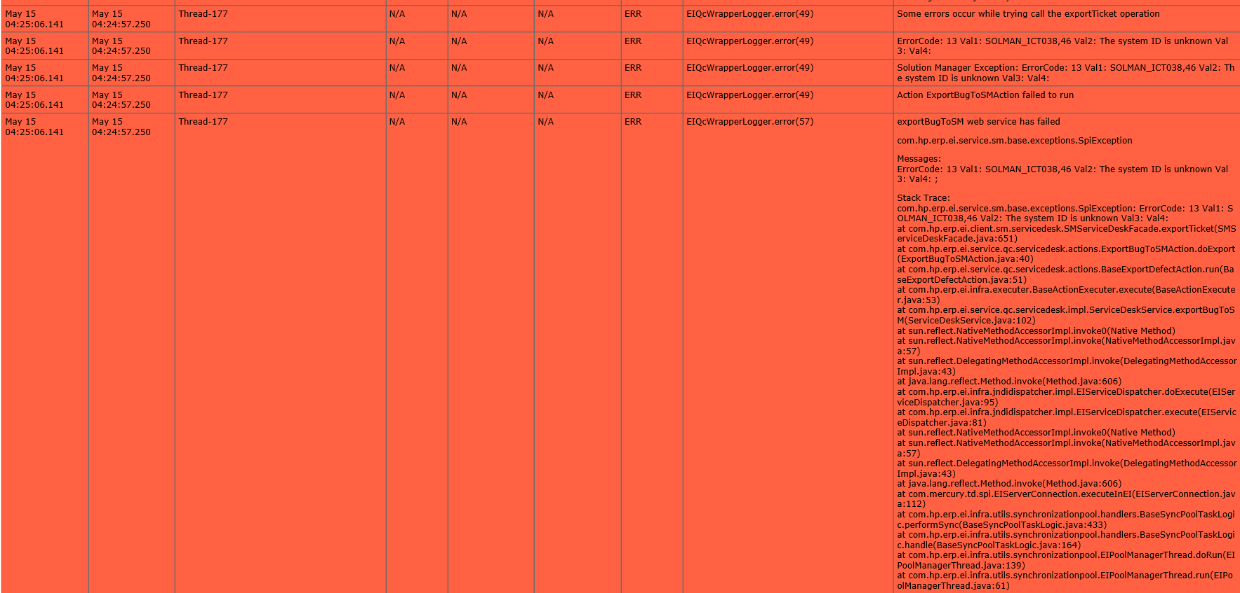

System ID is stored in table “APM_CLIENTS”

Check table Blueprint:

If the value of SPI_BL_EXTERNAL_GUID is stored after association

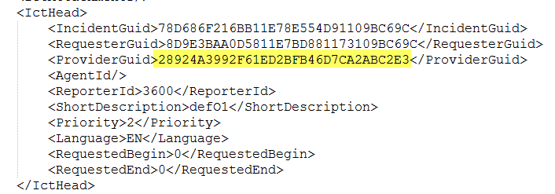

If not, try ictconf and reassociation

Ictconf: (check, overwrite, reactive, save)

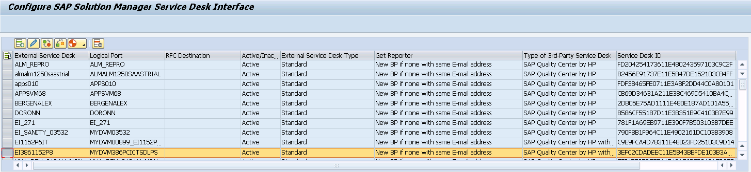

If in ictconf meet :

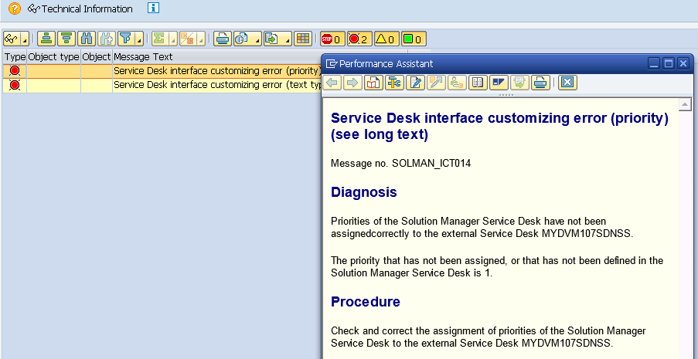

Reactive the logical port in lpconfig

Or need to save in each step (overwrite, activate, check, back and check the type)

If met connection failed, may need to wait a while and try again

#### For SolMan 7.2

And might due to application component is not add well in SolMan Setup – IT Service Management

Assign Responsibility(11.52P6, 12.21_3559)

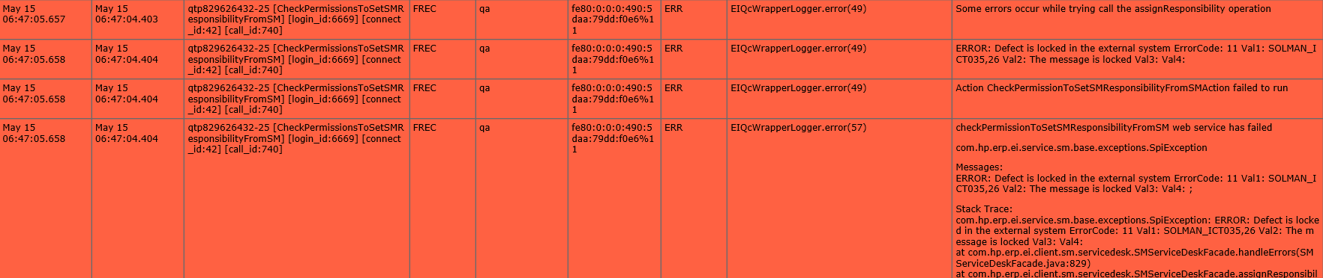

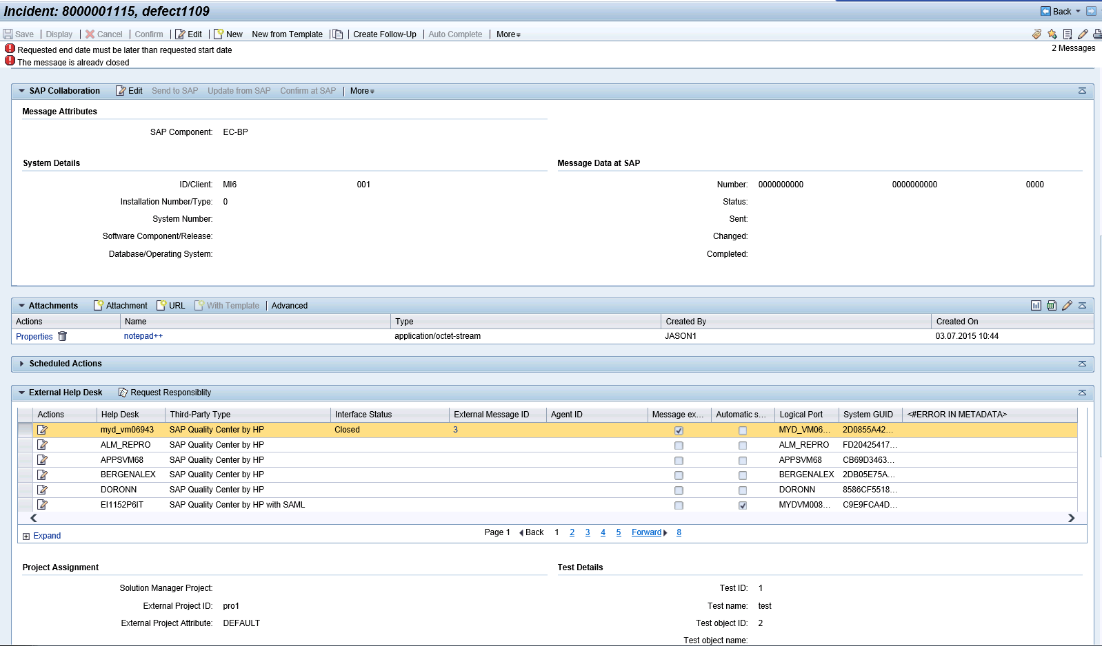

#### Timeout setting

EI_REQUEST_TIMEOUT in siteadmin, default is 60000 (60 second)

java.io.IOException: java.util.concurrent.TimeoutException: Idle timeout expired: 30038/30000 ms

*map issue*

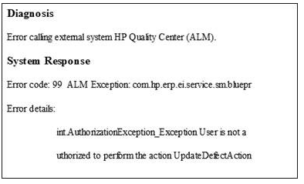

The user authentication issue could be caused by that user "ei_integration_user" is not in the project administrator group

Another cause might be: the value of "Solution Category’s" value changed on solman side.

There was a re-mapping for solution category necessary in ALM (the mapping is just stored in the database). In JVM, the mapping is loaded from the data base.

The mapping was still old version - so they needed to restart ALM server to reload it with new mapping’s value list of solman.

You can understand it as cache for platform performance. Need to remove cache to reload

## 7. BPCA

1. Click *Start Transaction*, the *Web Service Configuration* screen appears.
2. On the *Configuration* tab page, choose *Create Service*.
3. Enter the following data:
   * *Service name*: **AGS_BPCA_WS_API**
   * *Service Description Text*: Service AGS_BPCA_WS_API
   * *Binding Name*: **binding**
4. Choose *Next*.

This is very important as the tool is trying to read this exact endpoint name and in your case it cannot find them

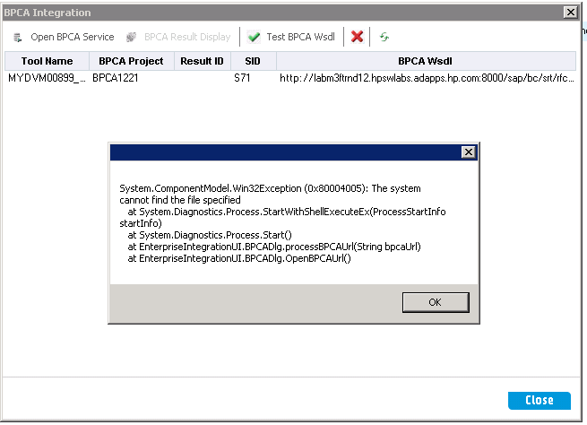

register tool in AGS_BPCA_3PTM_TOOL_REGISTRY again, and then reassociate project again, then it works fine

or maybe the project in solman is not configured with BOM object.

Or maybe the binding of AGS_BPCA_WS_API didn’t set using SAML as required

ii. when open BPCA service:

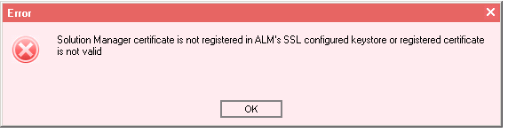

Might because “../program files/../java/../cacerts” missing ssl server certificate of solman

iii.when open service:

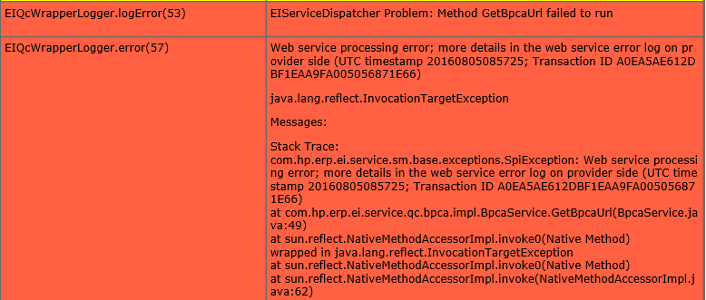

Check binding of BPCA custom proxy

About optimization:

If set Test Priority to be **10** or higher in ALM, then the test case will be neglected in optimization result

The reason why this happens is that the attribute values are handled as texts and not as numbers. Unfortunately there is no way to know whether an attribute contains text or numbers, so we handle it as text.

Now when you compare text then the comparison happens character by character from the right. So when comparing 5 and 10, 5 and 1 are compared first. 1 is lower than 5 and so 10 is lower as 5.

You can reach the behavior that you want by entering the priority values as 001, 002, …010, etc then you would get the desired behavior. As then 005 would be lower than 010.

## 8.Configuration

Site Admin:

ENTITY_LINK_HOST

ENTITY_LINK_PORT

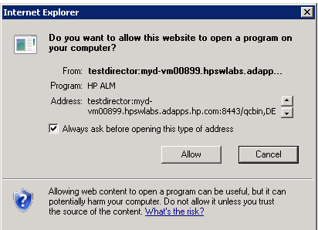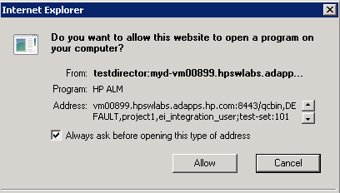

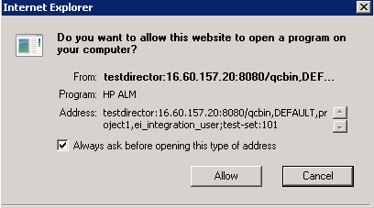

SECURED_QC_URL

value =Y

testdirector:**[S]**localhost:8443/qcbin,FLYING,BranchA,ei_integration_user;test-set:202

Log:

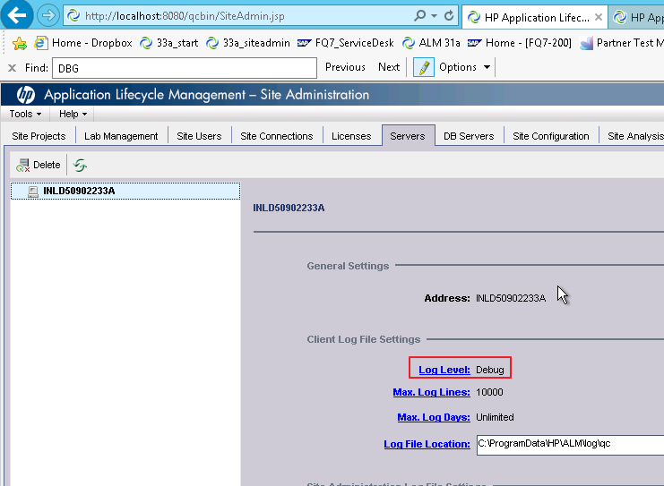

eiConfigFile.properties store the deployment path and ceritifcate info for run_ei_configurator.bat

If reinstall alm to different deployment path, this file need to be removed and will be create new one by run_ei_configurator.bat

## 9.Strange unstable issue:

1. the logical port of pcict none saml cannot be found in ictconf

Try open exist mapping and try again

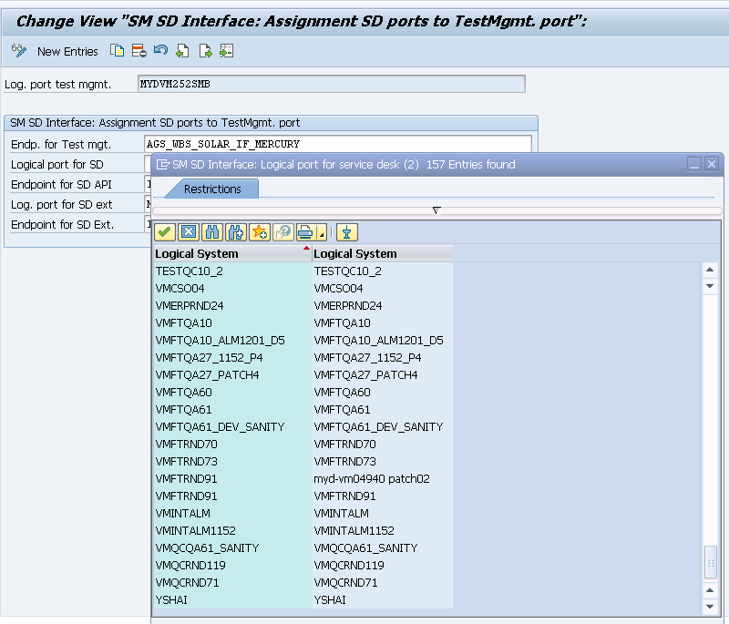

Tool: webgatelogger:

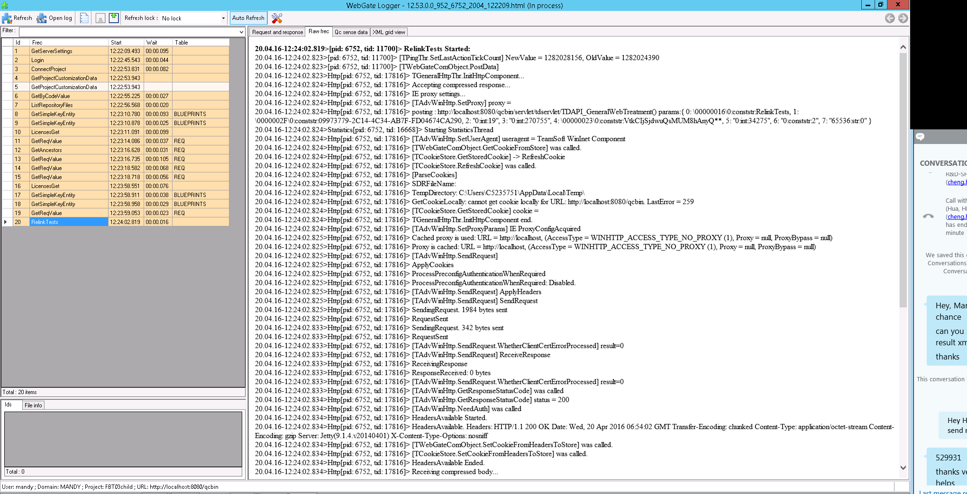

About dll and lld in ALM_Client:

(can manually copy *.lld to *.dll)

Mind the version:

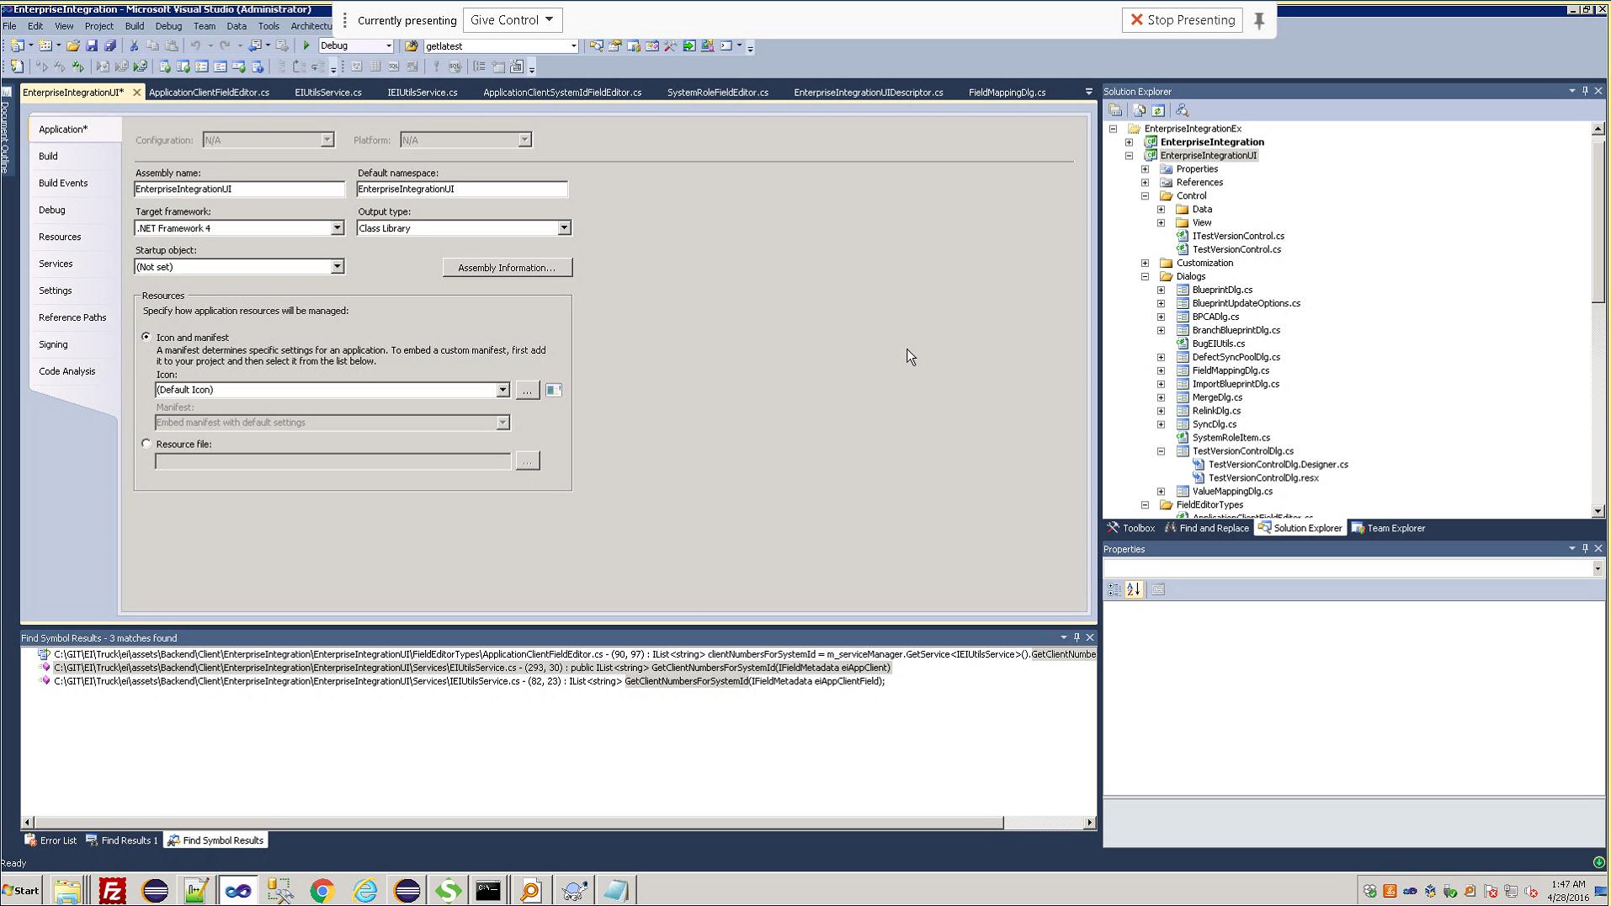

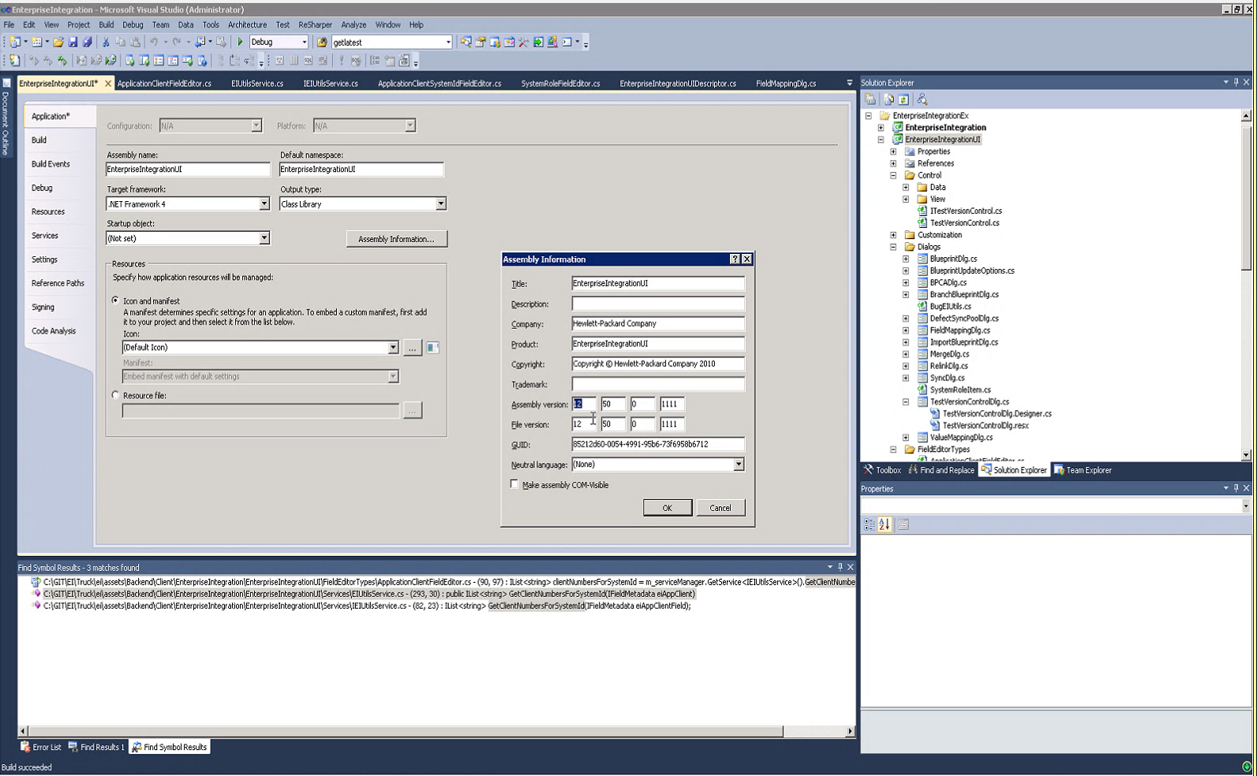

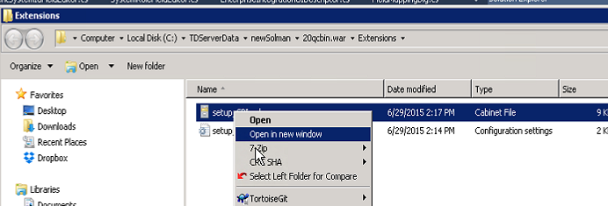

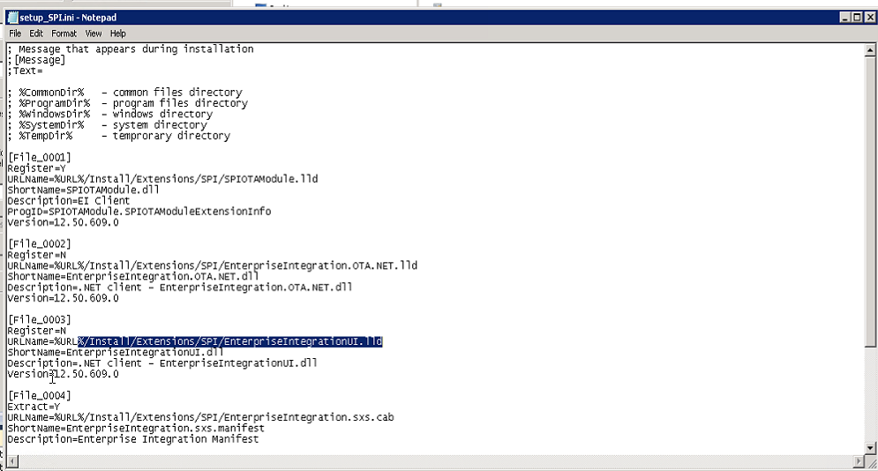

QC_for_SAP\EI\win32_release\EI12.53_Patch01\install\SPI\ProductDir\SPI.qcx\application\20qcbin.war\Install\Extensions\SPI

for the future reference, please make sure you copy the setup_spi.cab file too

from the above path

## 10. About build

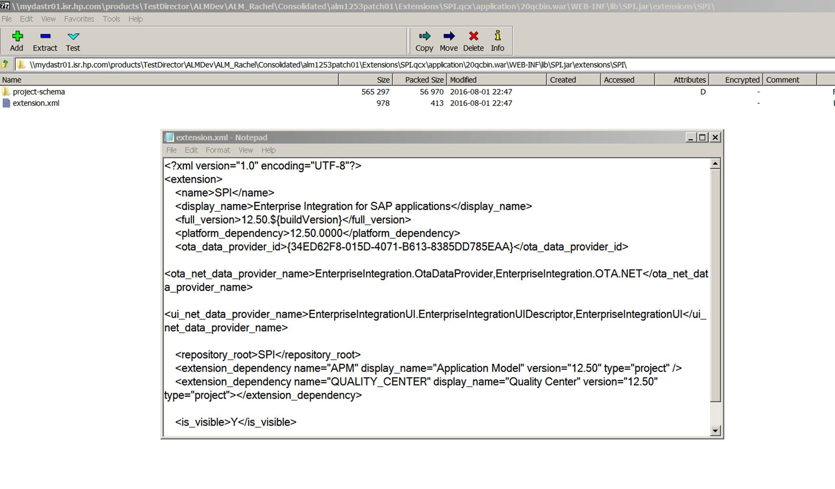

Below is my investigation, pls correct me for anything wrong.

1. SPI.jar is generated from EI-Compile-Server job.

From the log, Jenkins is passing the correct buildVersion and ProductBuildNumber

<http://mydtbld0093.hpeswlab.net:8888/jenkins/job/EI-Compile-Server/1206/console>

**02:44:10** D:\Jenkins\EI-12-53-build>C:\tools\Ant\apache-ant-1.8.2\bin\ant -f assets\Backend\Server\build.xml -DbuildVersion=2436 -DProductBuildNumber=12.53.2436.0 -DCodeSignProject=HPQualityCenter_Verisign build

1. Inside the build.xml, it is calling mvn

<http://mydtbld0005.hpeswlab.net:7990/projects/EIAP/repos/ei/browse/assets/Backend/Server/build.xml>

                                             <arg line="mvn" />

                                             <arg line="--batch-mode --errors -DbuildVersion=${ProductBuildNumber} install" />

## 11. About alm client

If delete alm loader (%appdata%/../HP/), need to launch ie in administrator role, then can start install

## 12. About db schema

i. If there is update in db_xmlmap.xml

Need to refresh cache by execute

update [qcsiteadmin_db].[td].[SEQUENCES] set sq_seq_value = sq_seq_value +1 where sq_seq_name ='MESSAGES'

delete Windows/Temp and %Temp%

check SPI.jar/extension/project-shema/12.50/db

restart alm

ii. If BPCA register table is delete during upgrade

<https://rndwiki.corp.hpecorp.net/confluence/display/qc/ALM+SA+extensions+extensibility+support>

If ALM cannot successfully connect to sa schema.

It is better to install a new ALM with new sa schema and then get the encrypted password string in installation path like “C:\ProgramData\HP\ALM\application\20qcbin.war\WEB-INF\siteadmin.xml”.

Replace current password string with it and retry.

note:

we don’t support two ALM instances on same server

The new ALM needs to be installed on another server

Export project missing two columns in BL_Test (#36167)

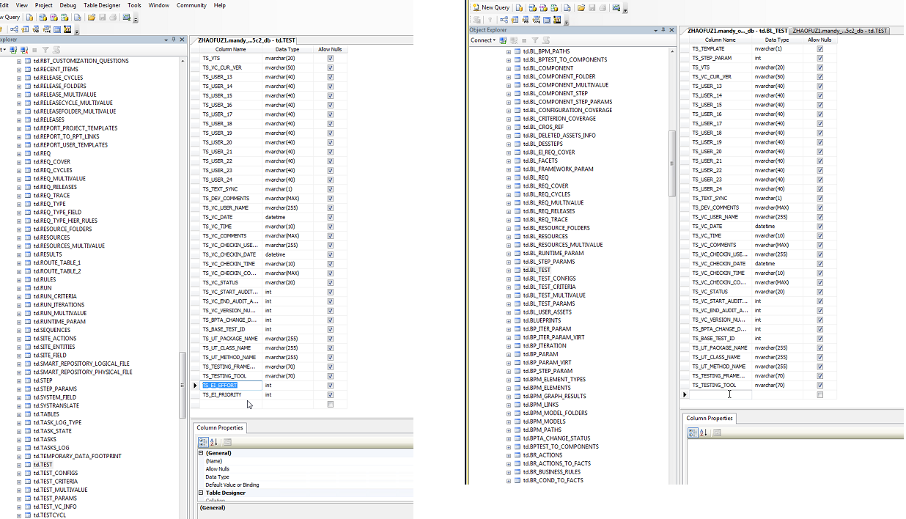

Upgrade 12.50 to 12.53, two useless indexes are removed

Details can be found in “Project with EI extension- ALM project migration from 1250Xto 12.53X..docx”  
Related Defect ID: 232218 Some columns in BL_TEST miss if export and import a project with EI&AM extensions

this just happen on exporting projects

sa schema:

Defect ID: 92665 8000003546, Is HP Enterprise Integration needed to …(http://alm7f.houston.softwaregrp.net/qcbin/start_a.jsp)

four sql sentences is for EI uprade when ALM upgrading from lower version to 12.5x. this limitation will disappear until ALM14

after the upgrade, you need to create two tables manually by the given sqls for SiteAdmin_DB

Two Tables Name: BLUEPRINT_PROJECTS,BPCA_REGISTRATION

Note: if there exist this two tables, and this two tables has datas,don't forget have a back-up for this two tables data,before you upgrade. you need to copy those data to the new tables(BLUEPRINT_PROJECTS,BPCA_REGISTRATION created my sql manually)

Details can be found in EI create tables manually for SiteAdmin_DB_12.5x.zip

## 13. About log4j.properties

log4j.logger.com.hp.alm.platform.performance = ERROR,QcLogAppender

log4j.logger.org.hp.qc.impl.performance.PerformanceMonitor=ERROR,QcLogAppender

# Settings for CXF

log4j.logger.org.apache.cxf = DEBUG,CONSOLE,QcLogAppender,QCRollingFileAppender

log4j.logger.org.apache.ws = DEBUG,CONSOLE,QcLogAppender,QCRollingFileAppender

# Settings for EI

log4j.logger.com.hp.ei = DEBUG,CONSOLE,QcLogAppender,QCRollingFileAppender

log4j.logger.com.hp.erp = DEBUG,CONSOLE,QcLogAppender,QCRollingFileAppender

## 14. About dns

If met DNS error, add ip and domain in hosts file

## 15. About Server Time

If met

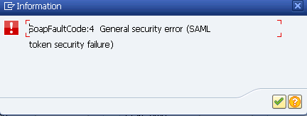

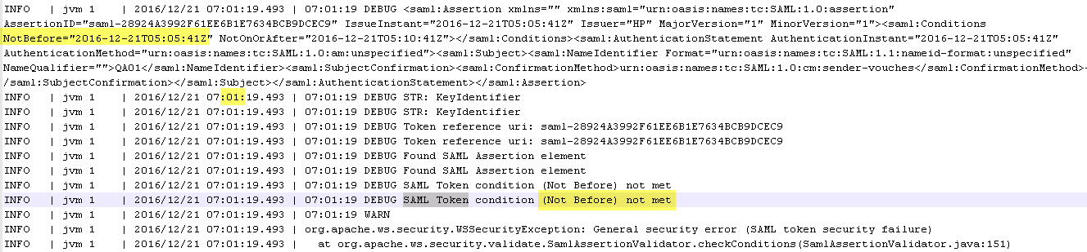

## 16. About DB export project

Export project and import to another ALM might meet one issue that column TS_EI_PRIORITY and TS_EI_EFFORT are missing in table BL_TEST

Right click on the imported project -> Maintain -> Repair , then the columns are added.

Or change ei schema, SPI.jar

(can only be fixed in 14)

## 17. About DB password

If user change password of td user and cannot launch ALM server and run_configuration.bat

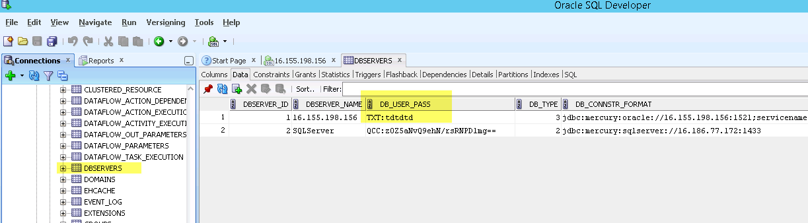

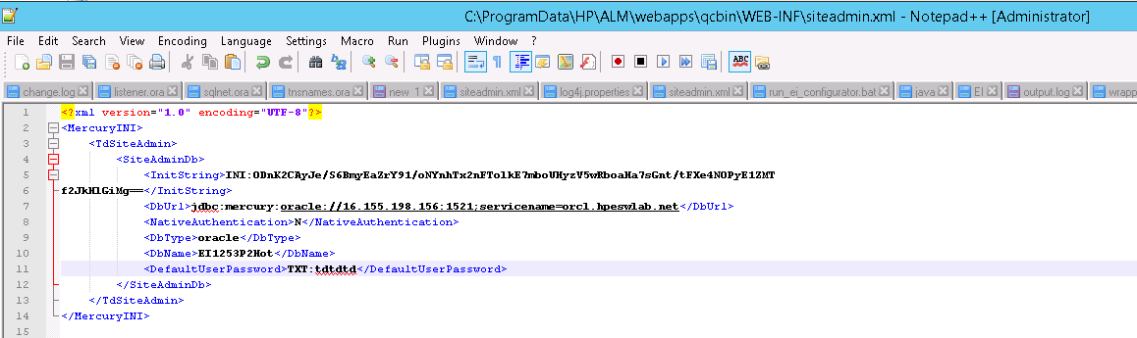

## 18. Authentication

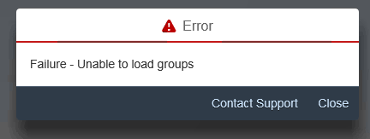

Authorization Object: SM_TS_PTM

Fields:

|  |  |
| --- | --- |
| **Field** | **Value** |
| ACTVT | 02 – Change; 03 – Display |
| SMWDCOMPON | WDC_ADAPTER_ADMIN_CENTER |

## 19. Secure port configure in SiteAdmin

when ALM is in SSL mode. you need to add one parameter in Site Configuration part

SECURED_QC_URL=Y

## 20. Merge and Sync

In 12.55, there is SQL error in backend if delete req_cov when req id is null in EI_Req_Cov

Workaround: check on “keep linkage”

Sync might not execute well if exist redundant record in library_mapping for same resources

SELECT * FROM LIBRARY_MAPPINGS where LMP_ENTITY_TYPE='RESOURCES'

If remove redundant record still sync not work, remove other record also

